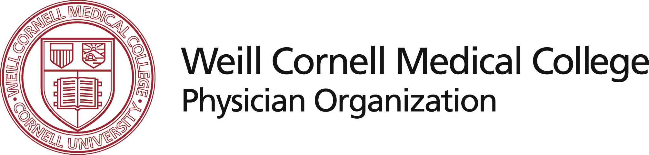

BREAST PATHOLOGY CONSULTATION SERVICE

NEW YORK PRESBYTERIAN HOSPITAL - WEILL CORNELL MEDICAL COLLEGE
DEPARTMENT OF PATHOLOGY AND LABORATORY MEDICINE
SANDRA J. SHIN, MD-CHIEF PAUL PETER ROSEN, MD-SR. CONSULTANT SYED A. HODA, MD
525 EAST 68TH STREET, STARR 1031 NEW YORK, NY 10065
PHONE: (212) 746-6482 FAX: (212) 746-6484

COMPLETE AND RETURN THIS FORM BY FAX FOR
SLIDE RETURN FORM

Please provide your courier account information. Return by FAX to (212) 746-6484.

OUR ACCESSION NUMBER: SC ______________________

INSTITUTION NAME: _______________________________

PATIENT NAME: ___________________________________

PATIENT DATE OF BIRTH: __________________________

CONTACT PERSON: ________________________________

TELEPHONE NUMBER: ( ) ______________________

PLEASE CHECK ONE:

( ) D H L EXPRESS ( ) FEDERAL EXPRESS

( ) UNITED PARCEL SERVICE (UPS)

( ) OTHER

YOUR COURIER ACCOUNT NUMBER: ____________________

Please Note: We require a minimum of 3 days from receipt in writing to process a request for return of slides and/or blocks. Materials will be shipped by 2-day service (unless otherwise indicated), billed to your account. Thank You

